Analyze the WSDL

**Exercise 4:**

**Problem Statement:**

To analyze the WSDL and perform one operation completely to find the request and response XML tags with their data types.

**Steps to execute:**

Given the WSDL, [**http://wsf.cdyne.com/WeatherWS/Weather.asmx?WSDL**](http://wsf.cdyne.com/WeatherWS/Weather.asmx?WSDL), analyze and produce the following information:

**1. Name of the Service described by this WSDL**

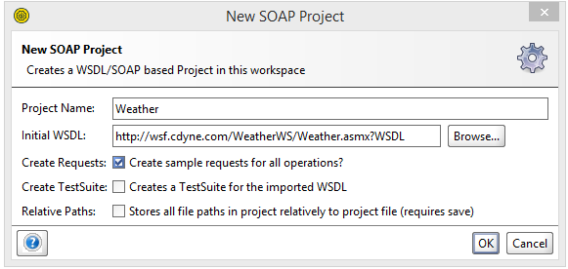

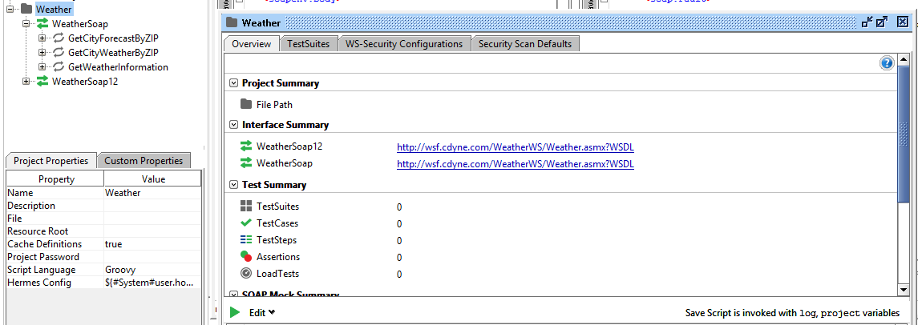

**2. Extract the endpoint for this service**

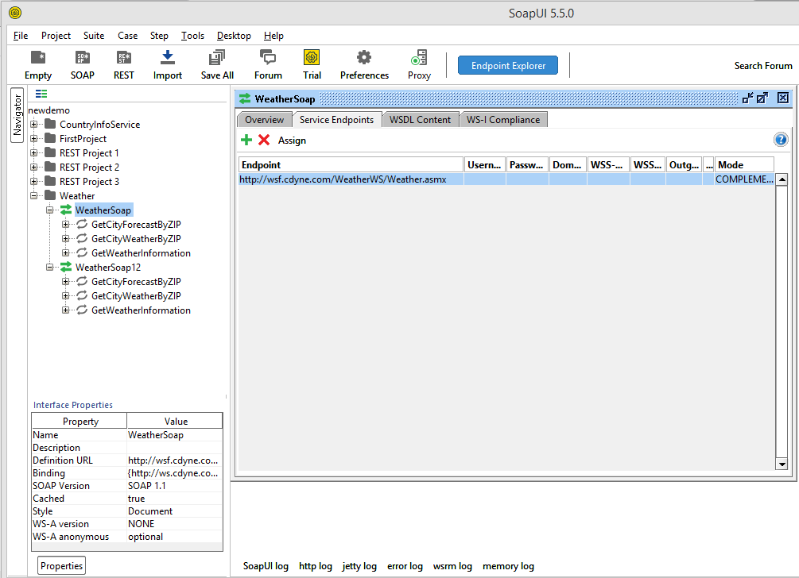

**3. List the count and name of the operations provided by this service**

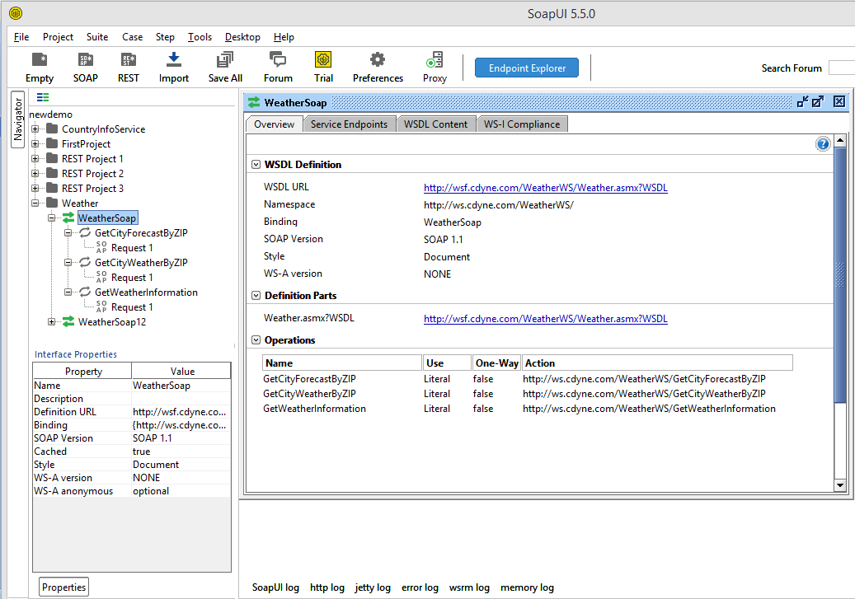

**4. Find the request and response XML tags with their data types, for at least one operation completely**

RESPOSNE XML

REQUEST XML

